**INSPIRA FRAMES**

Under guidance of

**MR. NIKHIL PANDEY**

Subject Matter Expert (Web Development)



**IBM, India Pvt Ltd.**

Dlf It Park 1 Tower-B, AF Block (Newtown), Area 1, Newtown, New Town, West Bengal

700156

**Submitted By**

**YASH SHAW**

**ANUPAM GHOSH**

**SOUVIK SIKDER**

**SOUVANIK PAL**

**SIMRAN GHOSH**

**Bachelor Of Computer Application**

**Kingston School of Management and Science**

Berunanpukhuria, Barasat, West Bengal 700126

* Name of the student:

**YASH SHAW**

**ANUPAM GHOSH**

**SOUVANIK PAL**

**SIMRAN GHOSH**

**SOUVIK SIKDER**

* Title of the project: **Stock Free Images Website**
* Name of the guide: **MR. NIKHIL PANDEY**
* Software used in the project:
* **VS CODE**

**Languages used** (HTML,CSS,JS)

* **MOZILLA FIREFOX**
* **GOOGLE CHROME**

1.

2.

3.

4.

5.

Signature of the Student

Date:

**For Office Use Only**

Approved

Not Approved

**Project Responsibility Form**

|  |  |  |
| --- | --- | --- |
| **SERIAL**  **NUMBER** | **NAME** | **Responsibility** |
| 1. | **YASH SHAW** | ***BACK-END-DEVELOPER*** |
| 2. | **YASH SHAW**  **ANUPAM GHOSH**  **SOUVIK SIKDER** | ***FRONT-END-DEVELOPER*** |
| 3. | **SOUVANIK PAL**  **SIMRAN GHOSH** | ***DOCUMENTATION*** |

Self-Certificate

This is to certify that the dissertation/project proposal entitled “**Stock Free Images Website**” is done by us, is an authentic work carried out for the partial fulfillment of the requirements for the award of the certificate of **Bachelor of Computer Application** under the guidance of **Mr. Nikhil Pandey**. The matter embodied in this project work has not been submitted earlier for award of any certificate to the best of our knowledge and belief.

**Name of the Students :**

1. YASH SHAW
2. ANUPAM GHOSH
3. SOUVANIK PAL
4. SIMRAN GHOSH
5. SOUVIK SIKDER

Signature of the students

a.

b.

c.

d.

e.

Certificate by Guide

This is to certify that this project entitled “**Stock Free Images Website** “submitted in partialfulfillment of the certificate of Bachelor of Computer Application through **IBM INDIA Pvt Ltd**, done by the Group Members

1. YASH SHAW
2. ANUPAM GHOSH
3. SOUVANIK PAL
4. SIMRAN GHOSH
5. SOUVIK SIKDER

is an authentic work carried out under my guidance & best of our knowledge and belief.

a.

b.

c.

d.

e.

Signature of the students Signature of the guide

Date: Date:





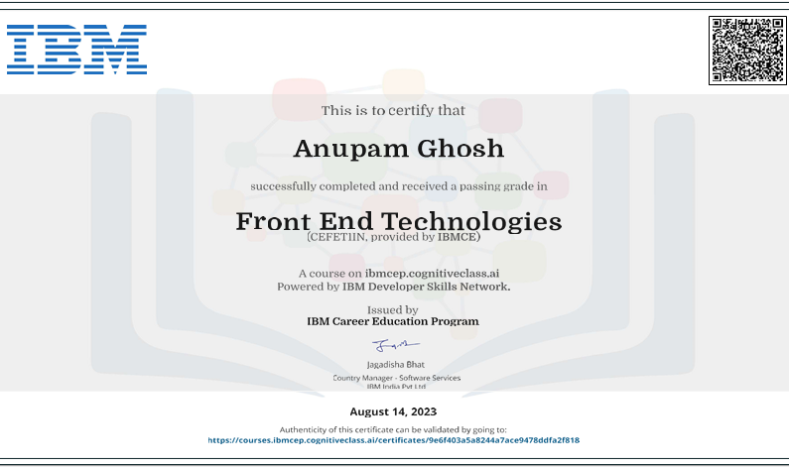







__________________________ ______________________________

**External Examiner(s) Head of the Department**

**Department of BCA**



Certificate of Approval

This is to certify that this proposal of Major project, entitled “**Stock Free Images Website**” is a record of bona-fide work, carried out by: 1: Yash Shaw, 2:Anupam Ghosh , 3:Simran Ghosh , 4: Souvanik Pal , 5: Souvik Sikder - under my supervision and guidance through the IBM India Pvt Ltd. In my opinion, the report in its present form is in partial fulfillment of all the requirements, as specified by the Kingston School of Management and Science as per regulations of the **IBM**. In fact, it has attained the standard, necessary for submission. To the best of my knowledge, the results embodied in this report, are original in nature and worthy of incorporation in the present version of the report for Bachelor of Technology.

**Guide/Superviso**r

**Mr. Nikhil Pandey** Subject Matter Expert (Web Development) IBM Kolkata Pvt Ltd Dlf It Park 1 Tower-B, AF Block (Newtown), Area 1, Newtown, New Town, West Bengal 700156

**External Examiner(s)**  **Head of the Department**

Department of BCA

Kolkata, W.B (Affiliated to MAKAUT,WB)

**STOCK FREE IMAGES WEBSITE**

Table of Contents

**1. IBM INDIA PVT. LTD : . 13**

**2.a. INTRODUCTION : 14**

**2.b. OBJECTIVE: 15**

**2.c. SCOPE : 16**

**3.a. IDENTIFICATION OF NEED : 17**

**3.b. FEASIBILITY STUDY : 18**

**3.c. WORK FLOW : 19**

#### 3.d. STUDY OF THE SYSTEM :…………………………………..22

**3.e. INPUT AND OUTPUT:……………………………………….23**

**3.f.SOFTWARE REQUIREMENT SPECIFICATIONS : .....................................................24**

3.g. SOFTWARE ENGINEERING PARADIGM APPLIED:………………………………………………………………..26

**4.a. DATA FLOW DIAGRAM 28**

**4.b. ENTITY RELATIONSHIP DIAGRAM 32**

**5.a. USER INTERFACE DESIGN 36**

**6.a INSPIRA FRAMES……………………………………………..41**

**6.b BENEFITS OF USING INSPIRA FRAMES……………………….42**

**7.a INSPIRA FRAMES- (HTML)………………………………...45**

**7.b INSPIRA FRAMES- (CSS)…………………………………….54**

**7.c INSPIRA FRAMES-(JS)……………………………………….57**

**IMPLEMENTATION AND TESTING…………………….63**

**ABOUT INSPIRA FRAMES……………………………………...69**

**FUTURE SCOPE AND FURTHER ENHANCEMENTS…………………………………………….73**

**CONCLUSION………………………………………………….76**

**BIBLIOGRAPHY……………………………………………….77**

# 1. IBM INDIA PVT. LTD.

IBM India Pvt Ltd, a global technology leader, spearheads innovation at the intersection of technology and business. With a rich legacy, it stands as a vanguard, driving transformative solutions through cutting-edge technologies.

Technologies at IBM India Pvt Ltd

IBM India Pvt Ltd is at the forefront of technological innovation, leveraging cutting-edge solutions to address complex business challenges. The company has embraced a wide array of technologies, including artificial intelligence (AI), cloud computing, blockchain, and data analytics. IBM's commitment to staying ahead in the tech landscape is evident through its emphasis on hybrid cloud solutions, enabling businesses to seamlessly integrate on-premises and cloud environments.The deployment of IBM Watson, the company's AI platform, has been instrumental in transforming industries by unlocking insights from vast datasets. IBM India has also been a pioneer in quantum computing research, pushing the boundaries of what's possible in computing. This dedication to diverse and advanced technologies cements IBM's position as a leader in the global tech ecosystem.

Collaborations at IBM India Pvt Ltd

IBM India Pvt Ltd actively engages in strategic collaborations with various entities to foster innovation and address complex business challenges. The company understands the significance of partnerships in today's interconnected world. Collaborative initiatives with academic institutions, startups, and industry leaders are a key component of IBM India's approach.Through collaborations, IBM India fosters an ecosystem that encourages knowledge exchange and skill development. The company's partnerships extend to research and development initiatives, creating synergies that drive technological advancements. By actively participating in industry consortia and open-source communities, IBM India contributes to the collective growth of the technology sector.

Associations at IBM India Pvt Ltd

IBM India Pvt Ltd values its associations with industry bodies, trade organizations, and forums that play a crucial role in shaping the business and technology landscape. Actively participating in these associations allows IBM India to contribute its expertise to policy discussions, standards development, and industry best practices.

Being part of associations strengthens IBM India's position as a thought leader in the tech industry.

# 2.a. INTRODUCTION

A stock images website serves as a comprehensive digital marketplace for high-quality, licensable photographs, illustrations, and graphics. These platforms provide a vast repository of visual content that caters to the diverse needs of individuals and businesses across various industries. Users can access a broad spectrum of images to enhance their creative projects, marketing materials, presentations, and more.

Typically, stock images websites offer a user-friendly interface, allowing visitors to search, preview, and purchase or download images based on their requirements. The content available on these platforms is often categorized and tagged, making it easy for users to find specific visuals relevant to their projects. The images are typically available in different resolutions and file formats, ensuring compatibility with various design applications.

One of the key advantages of stock images websites is the convenience they offer, eliminating the need for individuals or businesses to create custom visuals for every project. Licensing options vary, with choices ranging from royalty-free images for widespread use to rights-managed images for more exclusive purposes. This flexibility makes stock images websites a valuable resource for creative professionals, marketers, and anyone in need of compelling visuals to enhance their digital or print materials.

## 2.b. OBJECTIVE

The primary objective of a stock images website is to serve as a centralized hub for users, offering a diverse and extensive collection of licensable visual content. The platform aims to provide accessibility and convenience, allowing individuals and businesses to easily discover and acquire high-quality images, illustrations, and graphics for their creative projects. Emphasizing diversity and quality, these websites curate visuals spanning various themes, styles, and subjects to meet the diverse needs of creative professionals across different industries.

Beyond serving as a repository of visuals, stock images websites foster collaboration and community engagement. They encourage photographers and illustrators to contribute their work, creating a collaborative environment where users can interact and participate in the creative process. The platforms also offer flexible licensing options, including royalty-free and rights-managed, accommodating different usage scenarios and budget considerations.

As the digital landscape evolves, these websites expand their offerings to include multimedia elements such as videos, audio clips, and vector graphics. This adaptability ensures that users can find a wide range of resources to enhance their projects. Additionally, stock images websites focus on enhancing user experience through advanced search functionalities, curated collections, and personalized recommendations, creating a seamless and efficient creative workflow for their users.

### 2.c. SCOPE :

Stock images websites serve as versatile repositories, offering a vast array of licensable visual content, including images, illustrations, videos, and more, meeting the diverse needs of creative professionals.

* With an online presence, these platforms provide global accessibility, allowing users worldwide to tap into their extensive library of visuals, fostering a broad and diverse user base.Stock images websites encourage collaboration within a community of photographers and illustrators. This collaborative environment facilitates the sharing of creative ideas, contributing to a dynamic and evolving platform.
* Offering a range of licensing options, user-friendly interfaces, and diverse content, these platforms provide efficient and cost-effective solutions for creative professionals, streamlining the creative process and enhancing project outcomes. Stock images websites continually evolve to meet changing industry trends. This adaptability ensures that users have access to contemporary visuals, keeping their creative projects aligned with current design standards and preferences.

These platforms prioritize quality assurance, ensuring that the visual content meets high standards. From resolution options to file formats, users can expect consistent quality, enhancing the overall professionalism of their creative endeavors.

# 3.a. IDENTIFICATION OF NEED :

Understanding the need for a stock images website involves recognizing the demand for a centralized platform that provides diverse and high-quality visual content. This need arises from the challenges individuals and businesses face in acquiring professional-grade images, illustrations, and multimedia elements for their creative projects. The convenience, global accessibility, and cost-effectiveness offered by these platforms address the demand for efficient solutions in the ever-evolving landscape of digital media and design. Additionally, the collaborative community-driven aspect fulfills the need for a dynamic space where contributors and users can interact, fostering a continuous exchange of creative ideas.

Recognizing the need for a stock images website also stems from the desire for a streamlined creative workflow, allowing designers and marketers to access visuals quickly without the constraints of creating custom content for every project. The adaptability of these platforms to multimedia elements caters to the growing demand for diverse resources beyond static images, meeting the requirements of modern and dynamic digital projects.

## 3.b. FEASIBILITY STUDY :

Feasibility study is made to see if the project on completion will serve the purpose the organization for work. Feasibility study tried to determine whether a given solution would work or not.

Effort and the time that spend on it. Feasibility study lets the developer foresee the future of the project and the usefulness. A Feasibility study of a system proposal is according to its workability, which is the impact on the organization, ability to meet their user needs and effective use of resources. Thus, when a new application is proposed it normally goes through a feasibility study before it is approved for development.

The document provides the feasibility of the project that is being designed and lists various area that were considered very carefully during the feasibility study of this project such as Technical, Economic and operational feasibilities.

**1. Technical Feasibility:** A Technical Feasibility Study is an excellent tool for troubleshooting and long-term planning. This billing software is technically feasible. The software used is much faster and reliable than its counterparts and its usability makes it ideal for quick access to the hospital’s entire records.

**2. Economic Feasibility:** An Economic Feasibility Study is detail the costs that will be incurred by the organization adopting the new system; consider development costs and running costs. This billing software is economically feasible. The cost on project of hardware is low. The software loaded for this project was used even after this project was developed for many other applications.

**3. Operational Feasibility:** An Operational Feasibility Study is the measure of how well a proposed system solves the problems. This billing software is operationally feasible. The application was planned in such a way that no prior knowledge was required to go through the various operations.

### 3.c. WORK FLOW :

The Waterfall Model was first Process Model to be introduced. It is also referred to as a linear-sequential life cycle model. It is very simple to understand and use. In a waterfall model, each phase must be completed before the next phase can begin and there is no overlapping in the phases.

Waterfall model is the earliest SDLC approach that was used for software development.

The waterfall Model illustrates the software development process in a linear sequential flow; hence it is also referred to as a linear-sequential life cycle model. This means that any phase in the development process begins only if the previous phase is complete. In waterfall model phases do not overlap.

Waterfall Model design

Waterfall approach was first SDLC Model to be used widely in Software Engineering to ensure success of the project. In "The Waterfall" approach, the whole process of software development is divided into separate phases. In Waterfall model, typically, the outcome of one phase acts as the input for the next phase sequentially.

Following is a diagrammatic representation of different phases of waterfall model.

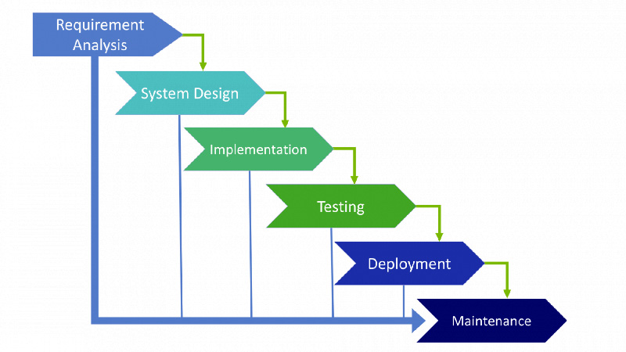

**The sequential phases in Waterfall model are:**

* **Requirement Gathering and analysis:** All possible requirements of the system to be developed are captured in this phase and documented in a requirement specification doc.
* **System Design:** The requirement specifications from first phase are studied in this phase and system design is prepared. System Design helps in specifying hardware and system requirements and also helps in defining overall system architecture.
* **Implementation:** With inputs from system design, the system is first developed in small programs called units, which are integrated in the next phase. Each unit is developed and tested for its functionality which is referred to as Unit Testing.
* **Integration and Testing:** All the units developed in the implementation phase are integrated into a system after testing of each unit. Post integration the entire system is tested for any faults and failures.
* **Deployment of system:** Once the functional and non-functional testing is done, the product is deployed in the customer environment or released into the market.
* **Maintenance:** There are some issues which come up in the client environment. To fix those issues patches are released. Also, to enhance the product some better versions are released. Maintenance is done to deliver these changes in the customer environment.

All these phases are cascaded to each other in which progress is seen as flowing steadily downwards (like a waterfall) through the phases. The next phase is started only after the defined set of goals are achieved for previous phase and it is signed off, so the name "Waterfall Model". In this model phases do not overlap.

Waterfall Model Application

Every software developed is different and requires a suitable SDLC approach to be followed based on the internal and external factors. Some situations where the use of Waterfall model is most appropriate are:

• Requirements are very well documented, clear and fixed.

• Product definition is stable.

• Technology is understood and is not dynamic.

• There are no ambiguous requirements.

• Ample resources with required expertise are available to support theproduct.

• The project is short.

The advantage of waterfall development is that it allows for departmentalization and control. A schedule can be set with deadlines foreach stage of development and a product can proceed through thedevelopment process model phases one by one.

Development moves from concept, through design, implementation, testing, installation, troubleshooting, and ends up at operation and maintenance. Each phase of development proceeds in strict order.

#### 3.d. STUDY OF THE SYSTEM :

Modules:

The modules used in this software are as follows:

• HOME: The homepage features a prominent search function for efficient navigation. Coupled with a captivating animated canvas, the site provides a visually engaging experience. The dynamic canvas, thoughtfully designed for responsiveness, adds a touch of creativity, enhancing user interaction and making the website both functional and visually appealing.

• ABOUT-US: The about page on our website provides insights into the vision and functionality of our platform, Inspira Frames. Discover the seamless integration of technology and creativity, fueled by the Unsplash API. Meet our dedicated team and learn about ongoing improvements and future benefits, ensuring a captivating and innovative user experience.

• PRIVACY POLICY: Our Privacy Policy page outlines how Inspira Frames handles user data. We're committed to transparency, informing users about data collection, usage, and security measures. By integrating the Unsplash API, we adhere to Unsplash's terms and privacy policy. We strive to continually enhance privacy features, ensuring a secure and trustworthy experience.

##### 3.e. INPUT AND OUTPUT :

Input Functionality:

* Users can enter search queries in the input field.
* The "Search" button triggers fetching images related to the query.

Output Functionality:

* Images are dynamically displayed in a styled container.
* The website automatically loads default images on startup.

**3.f.SOFTWARE REQUIREMENT SPECIFICATIONS :**

Software Requirements Specification provides an overview of the entire project. It is a description of a software system to be developed, laying out functional and nonfunctional requirements. The software requirements specification document enlists enough and necessary requirements that are required for the project development. To derive the requirements, we need to have clear and thorough understanding of the project to be developed. This is prepared after the detailed communication with project team and the customer.

The developer is responsible for:-

* Developing the system, which meets the SRS and solving all the requirements of the
* system?
* Demonstrating the system and installing the system at client’s location after acceptance testing is successful.
* Submitting the required user manual describing the system interfaces to work on it and also the documents of the system.
* Conducting any user training that might be needed for using the system.
* Maintain the system for a period of one year after installation.

**HARDWARE REQUIREMENTS:**

• Computer that has a 1.6GHz or faster processor

• 1 GB (32 Bit) or 2 GB (64 Bit) RAM (Add 512 MB if running in a virtual machine)

• HDD 20 GB Hard Disk Space and Above Hardware Requirements

• 5400 RPM hard disk drive

• DVD-ROM Drive

**SOFTWARE REQUIREMENTS:**

a. VS Code

b. Google Chrome

c. Fire Fox

3.g. SOFTWARE ENGINEERING PARADIGM APPLIED

Software paradigms refer to the methods and steps, which are taken while designing the software. There are many methods proposed and are in work today, but we need to see where in the software engineering these paradigms stand. These can be combined into various categories, though each of them is contained in one another.

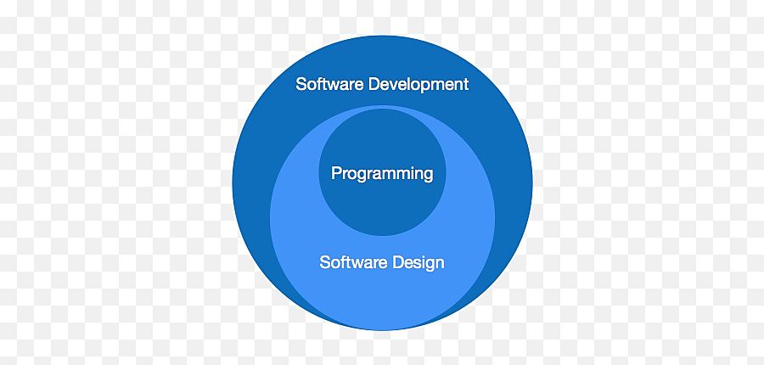

Programming paradigm is a subset of Software design paradigm which is further a subset of Software development paradigm.

There are two levels of reliability. The first is meeting the right requirement. A carefully and through systems study is needed to satisfy this aspect of reliability. The second level of systems reliability involves the actual working delivered to the user. At this level, the systems reliability is interwoven with software engineering and development. There are three approaches to reliability.

1. Error avoidance: Prevents errors from occurring in software.

2. Error detection and correction: In this approach errors are recognized whenever they are encountered and correcting the error by effect of error of the system does not fail.

3. Error tolerance: In this approach errors are recognized whenever they occur, but enables the system to keep running through degraded performance or Appling values that instruct the system to continue process.

Maintenance:

The key to reducing need for maintenance, while working, if possible, to do essential tasks.

1. More accurately defining user requirement during system development.

2. Assembling better systems documents.

3. Using some effective methods for designing, processing, and login and communicating information with project team members.

4. Making better use of existing tools and techniques.

# 4.a. DATA FLOW DIAGRAM

A **data flow diagram (DFD)** is a graphical representation of the "flow" of data through an information system, modelling its process aspects. A DFD is often used as a preliminary step to create an overview of the system, which can later be elaborated.

DFDs can also be used for the visualization of data processing (structured design).

A DFD shows what kind of information will be input to and output from the system, where the data will come from and go to, and where the data will be stored. It does not show information about the timing of process or information about whether processes will operate in sequence or in parallel (which is shown on a flowchart).

This context-level DFD is next "exploded", to produce a Level 1 DFD that shows some of the detail of the system being modeled. The Level 1 DFD shows how the system is divided into sub-systems (processes), each of whi1ch deals with one or more of the data flows to or from an external agent, and which together provide all of the functionality of the system as a whole. It also identifies internal data stores that must be present in order for the system to do its job, and shows the flow of data between the various parts of the system.

Data flow diagrams are one of the three essential perspectives of the structured-systems analysis and design method SSADM. The sponsor of a project and the end users will need to be briefed and consulted throughout all stages of a system's evolution. With a data flow diagram, users are able to visualize how the system will operate, what the system will accomplish, and how the system will be implemented. The old system's dataflow diagrams can be drawn up and compared with the new system's data flow diagrams to draw comparisons to implement a more efficient system. Data flow diagrams can be used to provide the end user with a physical idea of where the data they input ultimately has an effect upon the structure of the whole system from order to dispatch to report.

How any system is developed can be determined through a data flow diagram model.

In the course of developing a set of leveled data flow diagrams the analyst/designer is forced to address how the system may be decomposed into component sub-systems, and to identify the transaction data in the data model.

Data flow diagrams can be used in both Analysis and Design phase of the SDLC.

There are different notations to draw data flow diagrams. defining different visual representations for processes, data stores, data flow, and external entities.

**DFD NOTATION :**

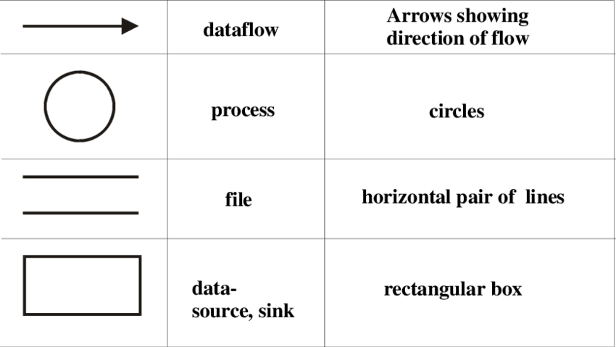

DFD EXAMPLE

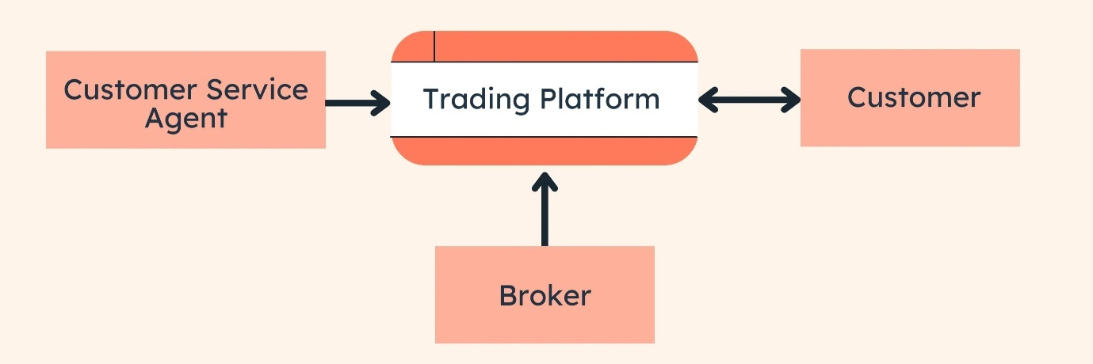

Steps to Construct Data Flow Diagram:-

Four Steps are generally used to construct a DFD.

* Process should be named and referred for easy reference. Eachname should be representative of the reference.
* The destination of flow is from top to bottom and from left to right.
* When a process is distributed into lower level details they arenumbered.
* The names of data stores, sources and destinations are written incapital letters.

Rules for constructing a Data Flow Diagram:-

* Arrows should not cross each other.
* Squares, Circles, Files must bear a name.
* Decomposed data flow squares and circles can have same names.
* Draw all data flow around the outside of the diagram.

**DATA FLOW DIAGRAM**

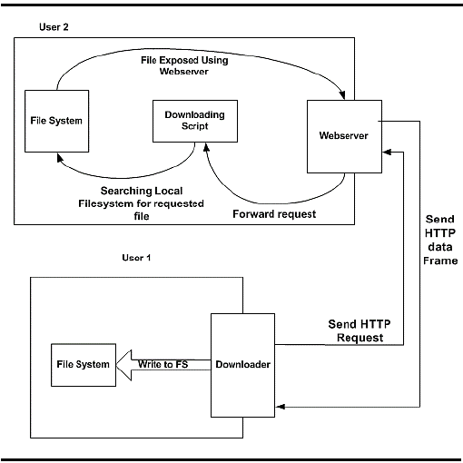

## 4.b. ENTITY RELATIONSHIP DIAGRAM

In software engineering, an entity–relationship model(ER model) is a data model for describing the data or information aspects of a businessdomain or its process requirements, in an abstract way that lends itself to ultimately being implemented in a database such as a relational. The main components of ER models are entities (things) and the relationships that can exist among them.

An entity–relationship model is the result of using a systematic process to describe and define a subject area of business data. It does not definebusiness process; only visualize business data. Entities may have variousproperties (attributes) that characterize them. Diagrams created to represent these entities, attributes, and relationships graphically are called entity–relationship diagrams.

An ER model is typically implemented as a database. In the case ofa relational database, which stores data in tables, every row of each table represents one instance of an entity.

The three schema approach to software engineering uses three levelsof ER models that may be developed.

Conceptual data model

The conceptual ER model normally defines master reference data entities that are commonly used by the organization. Developing an enterprise-wide conceptual ER model is useful to support documenting the data architecture for an organization. A concept ER model may be used as the foundation for one or more logical data models. The purpose of the conceptual ER model is then to establish structural metadata commonality for the master data entities between the set of logical ER models. The conceptual data model may be usedto form commonality relationships between ER models as a basis for data model integration.

* **Logical data model:**

The logical ER model contains more detail than the conceptual ER model. In addition to master data entities, operational and transactional data entitiesare now defined. The details of each data entity are developed and the relationships between these data entities are established. The logical ER model is however developed independent of technology into which it canbe implemented.

* **Physical data model:**

One or more physical ER models may be developed from each logical ER model. The physical ER model is normally developed to be instantiatedas a database. Therefore, each physical ER model must contain enough detail to produce a database and each physical ER model is technology dependent since each database management system is somewhat different. The physical model is normally instantiated in the structural metadata ofa database management system as relational database objects such as database tables, database indexes such as unique key indexes, and database constraints such as a foreign key constraint or a commonality constraint. The ER model is also normally used to design modifications tothe relational database objects and to maintain the structural metadata of the database.

The first stage of information system design uses these models during the requirements analysis to describe information needs or the type of information that is to be stored in a database. The data modeling technique can be used to describe any ontology for a certain area of interest.

Cardinality constraints are expressed as follows:

• A double line indicates a participation constraint, **totality** or **subjectivity**:all entities in the entity set must participate in at least one relationship in the relationship set;

• An arrow from entity set to relationship set indicates a **key constraint**,i.e., **injectivity**: each entity of the entity set can participate in at mostone relationship in the relationship set;

• A thick line indicates both, i.e., **bijectivity**: each entity in the entity setis involved in exactly one relationship.

• An underlined name of an attribute indicates that it is a **key**: two different entities or relationships with this attribute always havedifferent values for this attribute.

# 5.a. USER INTERFACE DESIGN

User interface (UI) design or user interface engineering is the design of user interfaces for machines and software, such as computers, home appliances, mobile devices, and other electronic devices, with the focus on maximizing usability and the user experience. In computer or software design, user interface (UI) design primarily focuses on information architecture. It is the process of building interfaces that clearly communicates to the user what's important. UI design refers to graphical user interfaces and other forms of interface design. The goal of user interface design is to make the user's interaction as simple and efficient as possible, in terms of accomplishing user goals. Interface design is involved in a wide range of projects, from computer systems, to cars, to commercial planes; all of these projects involve much of the same basic human interactions yet also require some unique skills and knowledge. As a result, designers tend to specialize in certain types of projects and have skills centered on their expertise, whether it Is software design, user research, web design, or industrial design

**Backend Implementation :**

The backend of the image search engine plays a crucial role in handling user queries, communicating with the index, and returning relevant search results. Here is a detailed explanation of the backend implementation:

**Query Processing :**

Upon receiving a user query through the user interface, the backend processes the query. This involves parsing and understanding the user's intent, extracting relevant information, and preparing it for further processing.

**Feature Extraction for Query Image :**

The backend extracts features from the query image using the same feature extraction methods employed during the indexing phase. This ensures consistency in representation and enables accurate comparison with indexed images.

**Similarity Calculation :**

The backend calculates the similarity between the features of the query image and the features stored in the image index. Common similarity metrics include cosine similarity or Euclidean distance. The goal is to identify images in the index that are most similar to the user's query.

**Result Ranking :**

Once similarities are calculated, the backend ranks the images based on their similarity scores. Images with higher similarity are given higher ranks, indicating their relevance to the user query.

**Result Retrieval :**

The backend retrieves the top-ranked images from the index and prepares them for presentation to the user. This involves fetching additional information associated with each image, such as metadata or tags.

**Response Generation :**

The backend generates a response to the user query, including the list of ranked images and relevant information. This response is then sent back to the user interface for display.

**Error Handling :**

The backend incorporates robust error handling mechanisms to address potential issues during query processing, feature extraction, or result retrieval. This ensures a smooth user experience and effective troubleshooting.

**Scalability and Performance :**

To handle varying levels of user requests, the backend is designed for scalability. This includes optimizing database queries, utilizing caching mechanisms, and implementing parallel processing where applicable to enhance performance.

**Security :**

Security measures are implemented to protect the backend from potential threats, such as unauthorized access, injection attacks, or data breaches. This may involve encryption of sensitive data, input validation, and regular security audits.

**Logging and Monitoring :**

The backend incorporates logging mechanisms to record important events and monitor system performance. This aids in debugging, identifying potential issues, and improving overall system health.

**Integration with Storage :**

Leveraging Unsplash's Image Storage Infrastructure:

Our project harnesses the robust image storage infrastructure provided by Unsplash through their API integration. Unsplash, a leading platform for high-quality, royalty-free images, offers a vast repository of diverse visuals hosted on their servers.

When users initiate a search on our website, the Unsplash API responds with a collection of image data, including unique URLs pointing directly to the stored images. These URLs are dynamically processed by our *displayImages* function to seamlessly integrate the visuals into our web interface.

This approach not only ensures a rich and varied selection of images for our users but also eliminates the need for us to host and manage a local image repository. By relying on Unsplash's storage system, we enhance the efficiency of our website, delivering a visually engaging experience without the associated overhead of local image storage and management.

In summary, our project capitalizes on the extensive and reliable image storage capabilities provided by Unsplash, offering users a diverse array of high-quality visuals while streamlining our website's operational efficiency.

Algorithmic Optimization:

Continuously refine and optimize the search algorithm. This may include exploring more efficient similarity metrics, tweaking parameters, and incorporating machine learning techniques to improve accuracy and speed in delivering search results.

Algorithmic optimization is an ongoing process that involves fine-tuning the core logic of the search algorithm. By experimenting with different parameters and exploring advanced similarity metrics, the goal is to strike a balance between precision and speed, ensuring that the image search engine provides relevant results swiftly. Additionally, staying abreast of developments in machine learning allows for the incorporation of cutting-edge techniques that can further enhance the overall performance and adaptability of the search algorithm to different types of images and user queries.

In the realm of algorithmic optimization, constant vigilance is maintained to analyse user feedback and iteratively improve the search algorithm. This iterative refinement process not only focuses on enhancing the accuracy of results but also considers the evolving nature of user preferences and search patterns. By incorporating user interactions and adjusting the algorithm accordingly, the image search engine aims to deliver a personalized and responsive experience, ensuring that the search results align closely with users' expectations and needs.

INSPIRA FRAMES

The name "**Inspira Frames**" suggests a platform that aims to inspire through visual elements, represented by "Frames." The word "Inspira" is likely derived from "inspire," indicating a source of creative motivation. Together, "Inspira Frames" implies a service dedicated to providing inspirational and visually appealing frames or images, possibly through integration with the Unsplash API.

**BENEFITS OF USING INSPIRA FRAMES**

Certainly! To highlight the benefits of using Inspira Frames, your website, you can consider the following points:

1. Vast and Diverse Image Collection:

Inspira Frames taps into Unsplash's extensive image library, providing users with access to a vast and diverse collection of high-quality, royalty-free images for various purposes.

1. Seamless User Experience:

The integration with Unsplash's API ensures a seamless and user-friendly experience. Users can easily search for and discover inspiring images without encountering delays or disruptions.

1. No Local Storage Overhead:

By leveraging Unsplash's image storage infrastructure, Inspira Frames eliminates the need for local storage of images. This not only reduces server space requirements but also simplifies website maintenance.

1. Dynamic Content Updates:

The dynamic content update feature ensures that users receive fresh and relevant content. Whether on the initial website load or during subsequent searches, Inspira Frames dynamically fetches and displays images based on user queries.

1. High-Quality Visuals for Various Projects:

Users can confidently use images from Inspira Frames in a wide range of projects, including web design, social media content, presentations, and more, thanks to the high quality and diversity of the available visuals.

1. Time and Resource Efficiency:

Inspira Frames optimizes resource usage by offloading the responsibility of image storage to Unsplash. This allows your team to focus on enhancing other aspects of the website and ensures efficient use of both time and resources.

1. Royalty-Free Accessibility:

All images available on Inspira Frames are sourced from Unsplash's extensive library of royalty-free images. Users can download and use these images without concerns about licensing or usage restrictions.

1. Scalability and Reliability:

Leveraging Unsplash's infrastructure ensures scalability and reliability. As your website grows, it can seamlessly accommodate increased user traffic and demands for image content without compromising on performance.

1. Community-Driven Inspiration:

Inspira Frames connects users with a global community of photographers contributing to Unsplash. This not only supports the creative community but also brings a collaborative and inspirational aspect to the platform.

1. Legal Compliance and Peace of Mind:

Users can use images from Inspira Frames with confidence, knowing that they adhere to Unsplash's terms and conditions. This legal compliance provides peace of mind for individuals and businesses utilizing the platform.

In summary, Inspira Frames offers a rich and efficient solution for accessing and incorporating high-quality, royalty-free images, enhancing the overall user experience and supporting a variety of creative projects.

**HTML**

<!DOCTYPE html>

<html lang="en">

<head>

<meta charset="UTF-8">

<meta name="viewport" content="width=device-width, initial-scale=1.0">

<link rel="shortcut icon" href="/if.png" type="image/x-icon" />

<title>INSPIRA FRAMES</title>

<link rel="stylesheet" href="/style.css">

<link rel="preconnect" href="https://fonts.googleapis.com">

<link rel="preconnect" href="https://fonts.gstatic.com" crossorigin>

<link href="https://fonts.googleapis.com/css2?family=Roboto:wght@500&display=swap" rel="stylesheet">

<link rel="preconnect" href="https://fonts.googleapis.com">

<link rel="preconnect" href="https://fonts.gstatic.com" crossorigin>

<link href="https://fonts.googleapis.com/css2?family=Dancing+Script:wght@700&family=Roboto:wght@500&display=swap" rel="stylesheet">

</head>

<body>

<div class="nav">

<ul>

<li><a id="logo" href="/">INSPIRA FRAMES</a></li>

<li><a id="home" href="/">Home</a></li>

<li><a id="about" href="/about.html">About</a></li>

<li><a id="privacy" href="/privacy.html">Privacy Policy</a></li>

</ul>

</div>

<canvas id="animatedCanvas"></canvas>

<p class="heading2">Welcome to...</p>

<h1 id="heading">INSPIRA FRAMES</h1>

<p class="heading2">find your perfect royalty-free image from over millions of high quality stunning stock images</p>

<form id="search-form">

<input type="text" id="search-box" placeholder="Search Images ... ">

<button>Search</button>

</form>

<div id="search-result"></div>

<button id="show-more-btn">Show more</button>

<canvas id="animatedCanvas1"></canvas>

<script src="/script.js"></script>

</body>

</html>

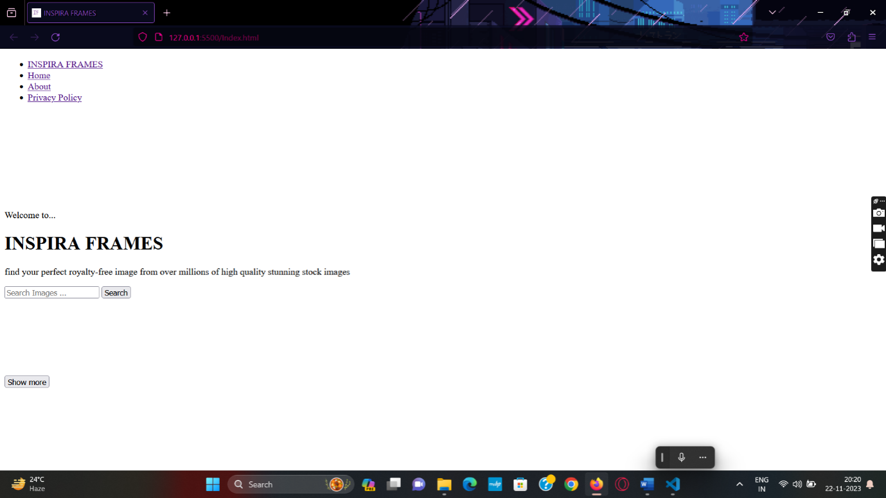

**PRIVACY**

<!DOCTYPE html>

<html lang="en">

<head>

<meta charset="UTF-8">

<meta name="viewport" content="width=device-width, initial-scale=1.0">

<link rel="shortcut icon" href="/if.png" type="image/x-icon" />

<title>Privacy Policy | Inspira Frames</title>

<link rel="preconnect" href="https://fonts.googleapis.com">

<link rel="preconnect" href="https://fonts.gstatic.com" crossorigin>

<link href="https://fonts.googleapis.com/css2?family=Dancing+Script:wght@700&family=Roboto:wght@500&display=swap" rel="stylesheet">

</head>

<style>

body {

font-family: 'Arial', sans-serif;

font-family: 'Roboto', sans-serif;

margin: 0px;

background-color: black;

color: white;

box-sizing: border-box;

}

header {

margin-bottom: 40px;

margin-top: 40px;

display: flex;

align-items: center;

justify-content: center;

}

section,

footer {

margin-bottom: 20px;

margin-left: 40px;

padding-left: 40px;

margin-right: 40px;

padding-right: 40px;

margin-bottom: 40px;

padding-bottom: 40px;

}

h1 {

text-align: center;

}

p {

line-height: 1.6;

}

.nav {

background-color: #ffffff;

color: #000000;

}

ul {

list-style-type: none;

padding: 0;

margin-left: 50px;

margin-top: 0px;

}

li {

display: inline-block;

margin: 20px;

}

li a {

font-family: 'Aerial', sans-serif;

font-weight: 600;

text-decoration: none;

color: #000000;

}

#logo{

font-family: 'Dancing Script', cursive;

color: rgb(13, 0, 95);

}

</style>

<body>

<div class="nav">

<ul>

<li><a id="logo" href="/">INSPIRA FRAMES</a></li>

<li><a id="home" href="/">Home</a></li>

<li><a id="about" href="/about.html">About</a></li>

<li><a id="privacy" href="/privacy.html">Privacy Policy</a></li>

</ul>

</div>

<header>

<h1>Inspira Frames - Privacy Policy</h1>

</header>

<section>

<h2>Introduction</h2>

<p>Welcome to Inspira Frames' Privacy Policy. This page informs you of our policies regarding the collection, use, and disclosure of personal data when you use our service and the choices you have associated with that data. By using Inspira Frames, you agree to the collection and use of information in accordance with this policy.</p>

</section>

<section>

<h2>Information Collection and Use</h2>

<p>We collect several different types of information for various purposes to provide and improve our service to you.</p>

</section>

<section>

<h2>Use of Data</h2>

<p>Inspira Frames uses the collected data for various purposes:</p>

<p>Additionally, Inspira Frames integrates with the Unsplash API to provide a curated selection of high-quality images. When you interact with the Unsplash API through our service, Unsplash's terms and conditions and privacy policy also apply. You can review Unsplash's policies on their website: <a href="https://unsplash.com/documentation/terms" target="_blank">Unsplash Terms</a> and <a href="https://unsplash.com/privacy" target="_blank">Unsplash Privacy Policy</a>.</p>

</section>

<section>

<h2>Disclosure of Data</h2>

<p>We may disclose personal information for legal or regulatory purposes or as otherwise described in this Privacy Policy.</p>

</section>

<section>

<h2>Security</h2>

<p>The security of your data is important to us, but remember that no method of transmission over the Internet or method of electronic storage is

secure. While we strive to use commercially acceptable means to protect your personal data, we cannot guarantee its absolute security.</p>

</section>

<section>

<h2>Links to Other Sites</h2>

<p>Our service may contain links to other sites that are not operated by us. If you click on a third-party link, you will be directed to that third party's site. We strongly advise you to review the Privacy Policy of every site you visit.</p>

</section>

<section>

<h2>Changes to This Privacy Policy</h2>

<p>We may update our Privacy Policy from time to time. We will notify you of any changes by posting the new Privacy Policy on this page.</p>

</section>

<footer>

<p>Thank you for using Inspira Frames! 💖</p>

</footer>

</body>

</html>

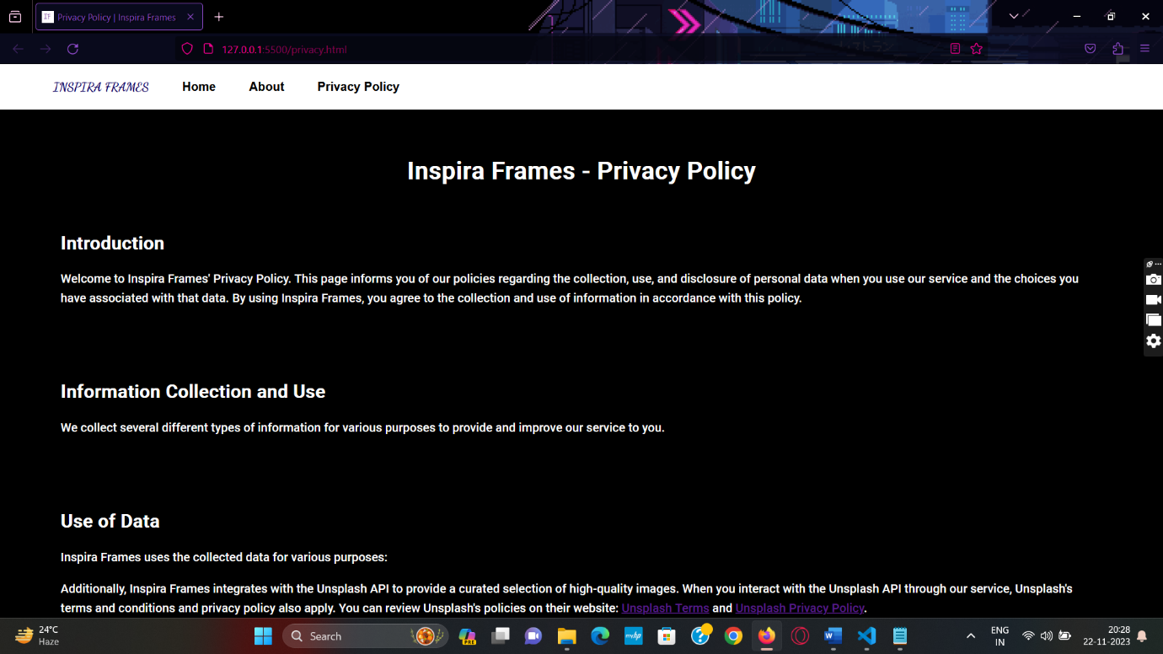**CSS**

*{

margin: 0;

padding: 0;

font-family:'poppins', sans-serif;

box-sizing:border-box ;

}

body{

background-color: #39297b;

color: #fff;

}

h1{

text-align: center;

margin: 100px auto 50px;

font-weight: 600;

}

form{

width: 90%;

max-width: 600px;

margin: auto;

height: 80px;

background-color: #434989;

display: flex;

align-items: center;

border-radius: 8px;

}

form input{

flex: 1;

height: 100%;

border: 0;

outline: 0;

background: transparent;

columns: #fff;

font-size: 18px;

padding: 0 30px;

}

form button{

padding: 0 40px;

height: 100%;

background-color: #ff3929;

columns: #fff;

font-size: 18px;

border: 0;

outline: 0;

border-top-right-radius: 8px;

border-bottom-right-radius: 8px;

cursor: pointer;

}

::placeholder{

color: #fff;

font-size: 18px;

}

#show-more-btn{

background-color:#ff3929;

color: #fff;

border: 0;

outline: 0;

padding: 10px 20px;

border-radius: 4px;

margin:10px auto 100px;

cursor: pointer;

display: none;

}

#search-result{

width: 80%;

margin: 100px auto 50px;

display: grid;

grid-template-columns: 1fr 1fr 1fr;

grid-gap: 40px;

}

#search-result{

width: 100%;

height: 230px;

object-fit: cover;

border-radius: 5px;

}

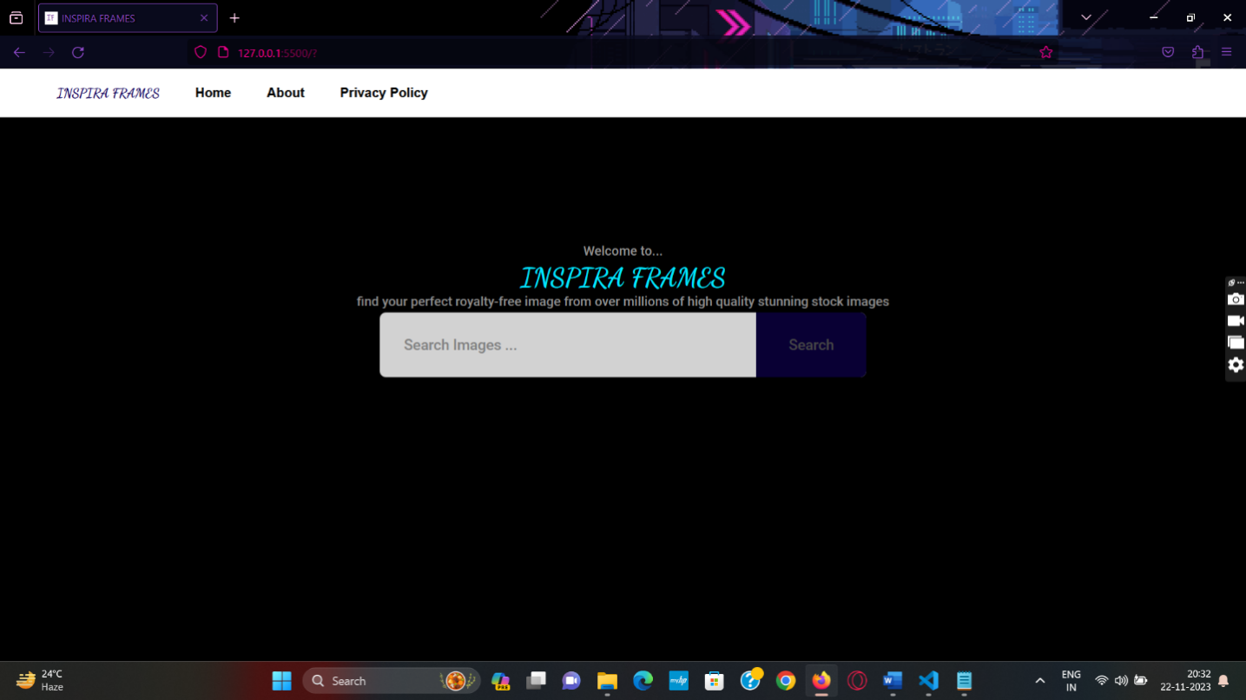

**JS SCRIPT**

const accessKey = "UvzpHaX9kJI5McwldaLW5vwMB9u3MqxlznZnSwE2SA0";

const searchForm = document.getElementById("search-form");

const searchBox = document.getElementById("search-box");

const searchResult = document.getElementById("search-result");

const showMoreBtn = document.getElementById("show-more-btn");

let keyword = "";

let page = 1;

async function searchImages() {

keyword = searchBox.value;

const url = `https://api.unsplash.com/search/photos?page=${page}&query=${keyword}&client_id=${accessKey}&per_page=12`;

const response = await fetch(url);

const data = await response.json();

if (page === 1) {

searchResult.innerHTML = "";

}

const results = data.results;

results.map((result) => {

const image = document.createElement("img");

image.src = result.urls.small;

const imageLink = document.createElement("a");

imageLink.href = result.links.html;

imageLink.target = "_blank";

imageLink.appendChild(image);

searchResult.appendChild(imageLink);

})

showMoreBtn.style.display = "block";

}

searchForm.addEventListener("submit", (e) => {

e.preventDefault();

page = 1;

searchImages();

});

showMoreBtn.addEventListener("click", () => {

page++;

searchImages();

});

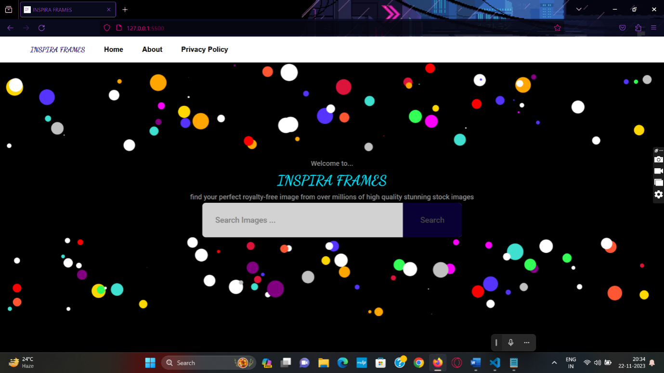

**EXAMPLE**

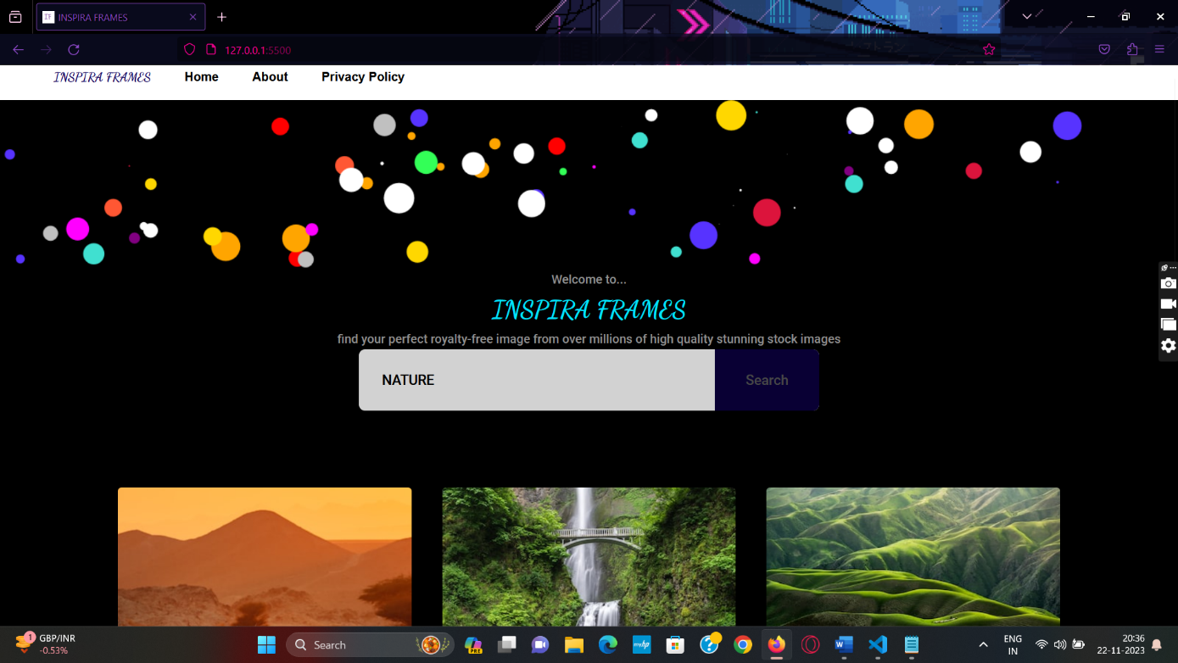

I searched for nature pictures and our website gives me some nature pictures ,here we can see the pictures

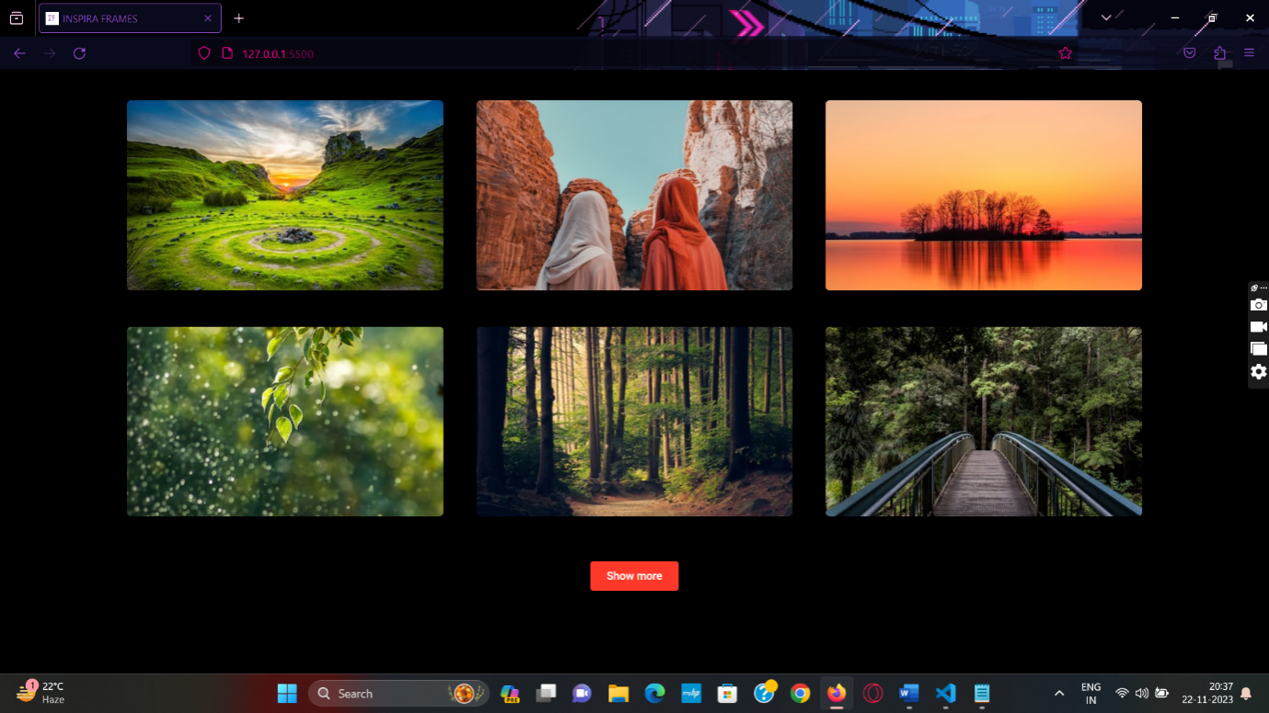

IF YOU NEED TO SEE MORE PICTURES ABOUT NATURE THEN CLICK “SHOW MORE” BUTTON

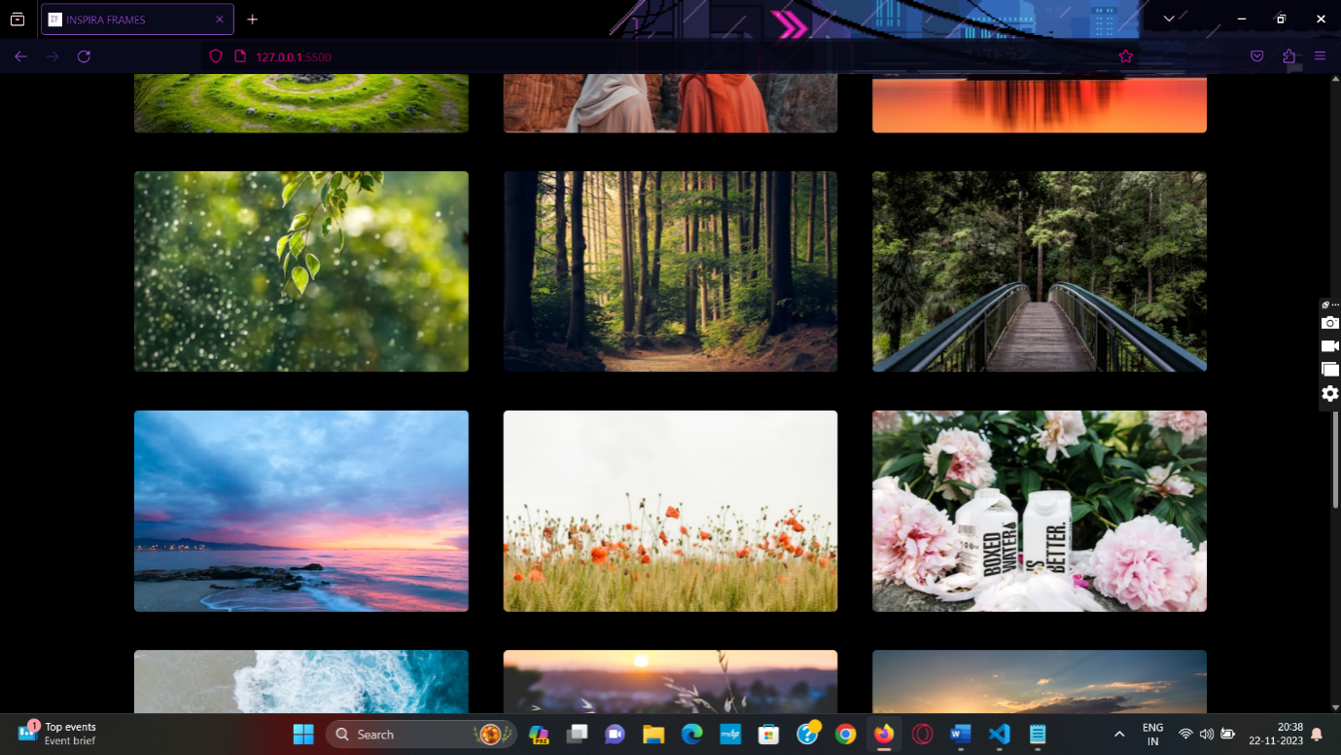

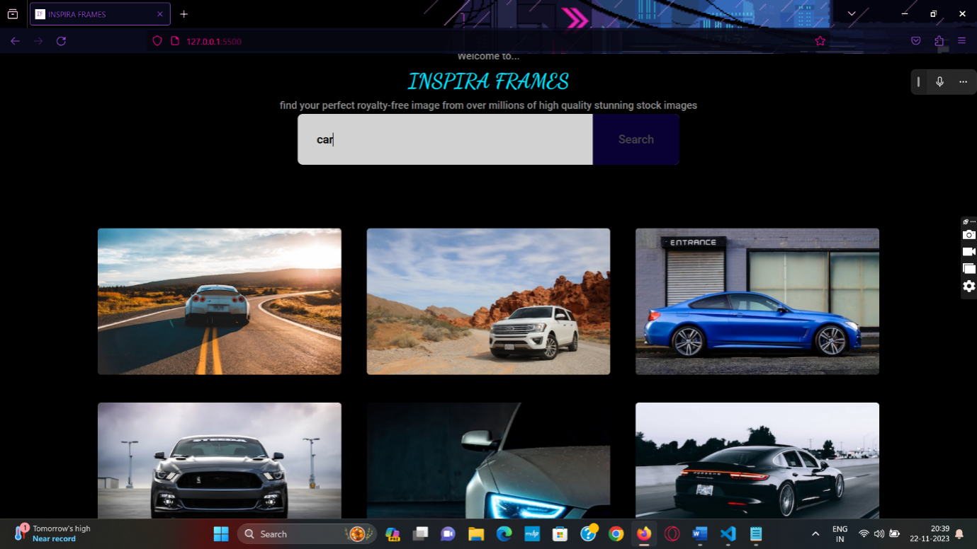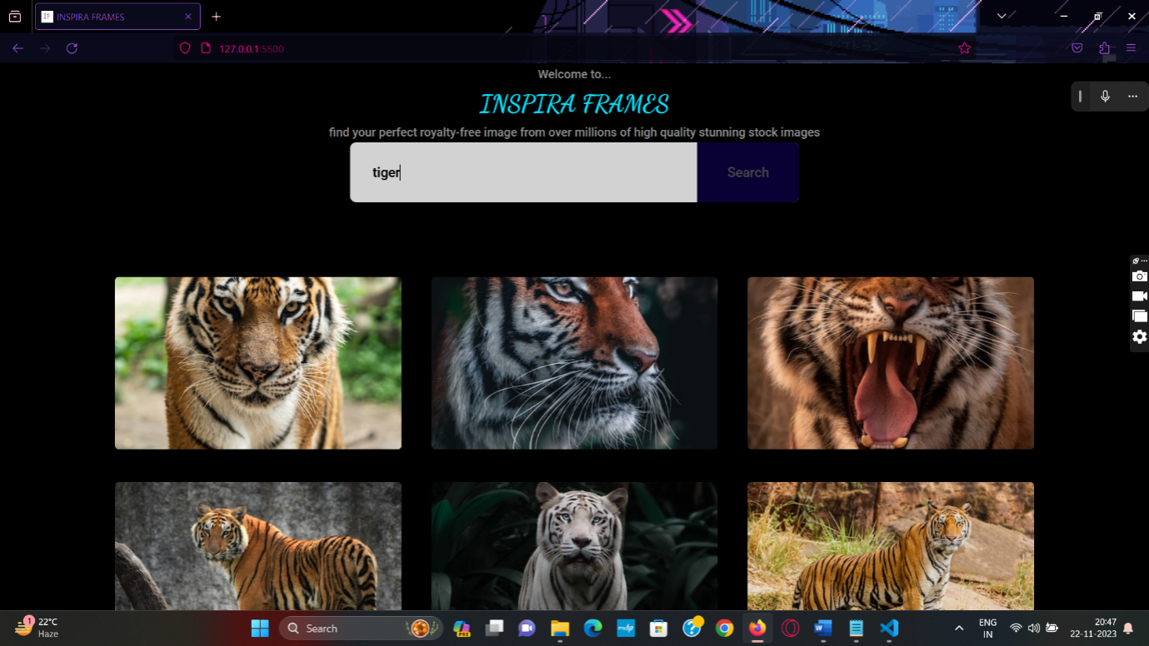

**Implementation and Testing :**

Implementation is the process of putting an action for the formulated plan. Before we implement, the planshould have been completed and our objectives should be clear. Testing each one of those actions formulated in the planis said to be implementation testing.

**INTRODUCTION :**

Implementation is the execution of the plan, or implement the idea or model, or design to do something. Also, is a procedure that must be followedin the initial thinking of something actually happen.Therefore, the implementation includes all the processes included in getting a new software or hardware work correctly in their environment, including installation, configuration, running, testing, and make the necessary changes. The chapter is organized as follows: Section 2 gives some information about validates is security, stability, and more.

**OBJECTIVES OFTESTING :**

A combination of various important and complex activities, software testing is one of the most critical processes performed during Software Development Life Cycle (SDLC). It is an amalgamation of various activities that are performed continuously, since the inception of the project. It helps verify and validate that the software meets the requirements of the client and works as per their expectations and requirements. Testing is an extremely beneficial and helpful activity that allows testers to establish the quality and performance of the software. In short, software testing guarantees proper functioning of the software and validates is security, stability, and more.

Process overview

1. Verification: A prominent objective of testing is verification, which allows testers to confirm that the software meets the various business and technical requirements stated by the client before the inception of the whole project.

2. Validation: Confirms that the software performs as expected and as per the requirements of the clients. Validation involves checking the comparing the final output with the expected output and then making necessary changes if there is a difference between the two.

3. Defects: The most important purpose of testing is to find different defects in the software to prevent its failure or crash during implementation or go live of the project. Defects if left undetected or unattended can harm the functioning of the software and can lead to loss of resources, money, and reputation of the client. Therefore, software testing is executed regularly during each stage of software development to find defects of various kinds.

4. Providing Information: With the assistance of reports generated during the process of software testing, testers can accumulate a variety of information related to the software and the steps taken to prevent its failure. These, then can be shared with all the stakeholders of the project for better understanding of the project as well as to establish transparency between members.

5. Preventing Defects: During the process of testing the aim of testes to identify defects and prevent them from occurring aging in the future. To accomplish this goal, software is tested rigorously by a independent testers, who are not responsible for software development.

6. Quality Analysis: Testing helps improve the quality of the software by constantly measuring and verifying its design and coding.

7. Compatibility: It helps validate application’s compatibility with the implementation environment, various devices, Operating Systems, user requirements, among other things.

8. For Optimum User Experience: Easy software and application accessibility and optimum user experience are two important requirements that need to be accomplished for the success of any project as well as to increase the revenue of the client. Therefore, to ensure this software is tested again and again by the testers with the assistance of stress testing, load testing, spike testing, etc.

9. Verifying Performance & Functionality: It ensures that the software has superior performance and functionality. This is mainly verified by placing the software under extreme stress to identify and measure its all plausible failure modes.

**TEST CASES**

A Test Case is a set of actions executed to verify a particular feature or functionality of your software application. A Test Case contains test steps, test data, precondition, and post condition developed for specific test scenario to verify any requirement.

**Unit Testing:**

The next phase of software testing is unit testing. During this phase, the software undergoes assessments of its specific units, or its functions and procedures, to ensure that each works properly on its own. The developers may use white box testing to evaluate the software's code and internal structure, commonly before delivering the software for formal testing by testers. Unit testing can occur whenever a piece of code undergoes change, which allows for quick resolution of issues.

**Integration Testing:**

Integration testing involves testing all the units of a program as a group to find issues with how the separate software functions interact with one another. Through integration testing, the developers can determine the overall efficiency of the units as they run together. This phase is important because the program's overall functionality relies on the units operating simultaneously as a complete system, not as isolated procedures.

**Validation:**

The definition of validation testing in software engineering is in place to determine if the existing system complies with the system requirements and performs the dedicated functions for which it is designed along with meeting the goals and needs of the organization. The software verification and validation testing is the process after the validation testing stage is secondary to verification testing.

**OUTPUT TESTING :**

Output testing for the Stock Image Website is a critical evaluation of its documented functionalities. It encompasses validating the accuracy of search results, ensuring a smooth download process, and confirming the clarity of image previews.

The examination extends to resolution and quality maintenance, verifying adherence to specified standards. Licensing information visibility is assessed, alongside testing bulk download efficiency and API integration accuracy. The website's responsiveness across diverse devices is scrutinized, and error handling mechanisms are thoroughly evaluated. By conducting this comprehensive output testing, the Stock Image Website aims to deliver a reliable and user-friendly experience, aligning closely with the documented guidelines to meet user expectations effectively.

**GOAL OF TESTING :**

The main goal of software testing is to find bugs as early as possible and fix bugs and make sure that the software is bug-free.

**INTEGRATION TEST REPORTS :**

Integration testing is known as the second level of the software testing process, following unit testing. Integration testing involves checking individual components or units of a software project to expose defects and problems to verify that they work together as designed. As a rule, the usual software project consists of numerous software modules, many of them built by different programmers. Integration testing shows the team how well these disparate elements work together.

**FUNCTIONAL TESTING:**

Functional testing is a type of testing that seeks to establish whether each application feature works as per the software requirements. Each function is compared to the corresponding requirement to ascertain whether its output is consistent with the end user’s expectations.

**ABOUT INSPIRA FRAMES**

**What We Do**

At Inspira Frames, we believe in the seamless integration of technology and creativity. Our platform leverages the vast and diverse collection of images available on Unsplash, one of the leading sources for high-quality, royalty-free photographs. With the power of the Unsplash API, we bring this vast visual library directly to your fingertips.

The Unsplash API Advantage

Unsplash is home to over a million high-resolution images, contributed by a community of talented photographers from around the globe. By integrating the Unsplash API into Inspira Frames, we empower you to effortlessly enhance your website, application, or project with beautiful, professionally captured visuals. The API provides access to a wealth of images spanning various categories, ensuring that you find the perfect visuals to complement your content.

**How It Works**

Inspira Frames simplifies the process of incorporating stunning images into your web environment. Through a user-friendly interface, you can easily search for images based on keywords, themes, or styles. The Unsplash API then seamlessly fetches and displays these images in real-time, ensuring that your digital space remains dynamic and engaging.

Our Mission

We are passionate about democratizing access to high-quality visuals for developers, designers, and content creators. Whether you're building a website, crafting a presentation, or developing an application, Inspira Frames aims to be your go-to solution for integrating captivating imagery effortlessly.

**Our Team**

Inspira Frames is brought to you by a dedicated team of creative individuals. Meet our team:

The most significant member and creator of this fabulous Web Application as well as our

Team Leader : ***Yash Shaw***

And other team members are mentioned below

***Anupam Ghosh***

***Souvanik Pal***

***Simran Ghosh***

***Souvik Sikder***

**Get Started**

Ready to elevate your digital presence? Explore the endless possibilities of Inspira Frames by diving into the Unsplash API. Get started today and transform your online experience with visually stunning images.

**INSPIRA FRAMES - PRIVACY POLIYCY**

**Introduction**

Welcome to Inspira Frames' Privacy Policy. This page informs you of our policies regarding the collection, use, and disclosure of personal data when you use our service and the choices you have associated with that data. By using Inspira Frames, you agree to the collection and use of information in accordance with this policy.

**Information Collection and Use**

We collect several different types of information for various purposes to provide and improve our service to you.

**Use of Data**

Inspira Frames uses the collected data for various purposes:

Additionally, Inspira Frames integrates with the Unsplash API to provide a curated selection of high-quality images. When you interact with the Unsplash API through our service, Unsplash's terms and conditions and privacy policy also apply. You can review Unsplash's policies on their website: Unsplash Terms and Unsplash Privacy Policy.

**Disclosure of Data**

We may disclose personal information for legal or regulatory purposes or as otherwise described in this Privacy Policy.

**Security**

The security of your data is important to us, but remember that no method of transmission over the Internet or method of electronic storage is secure. While we strive to use commercially acceptable means to protect your personal data, we cannot guarantee its absolute security.

**Links to Other Sites**

Our service may contain links to other sites that are not operated by us. If you click on a third-party link, you will be directed to that third party's site. We strongly advise you to review the Privacy Policy of every site you visit.

**Changes to This Privacy Policy**

We may update our Privacy Policy from time to time. We will notify you of any changes by posting the new Privacy Policy on this page.

**FUTURE SCOPE AND FURTHER ENHANCEMENTS :**

**The future scope and potential enhancements for Inspira Frames could include:**

1. **User Accounts and Collections:**

**Implement user accounts to allow users to create and manage their collections of favorite images.**

**Enable users to curate and share their collections, fostering a sense of community engagement.**

1. **Advanced Search Filters:**

**Integrate more advanced search filters, such as color, orientation, and image type, to provide users with precise control over their search results.**

1. **Personalization and Recommendations:**

**Implement personalized recommendations based on user search history and preferences, enhancing the user experience and encouraging return visits.**

1. **Social Media Integration:**

**Enable seamless sharing of images on popular social media platforms, allowing users to showcase their favorite finds and contribute to the platform's visibility.**

1. **API Key Management for Users:**

**Provide users with the ability to obtain their Unsplash API keys for enhanced personalization and control over their API usage.**

1. **Localized Content and Language Support:**

**Offer content localization options and support for multiple languages to cater to a global audience.**

1. **Collaboration Features:**

**Introduce collaborative features, such as allowing users to collaborate on image collections or projects, promoting teamwork and creative collaboration.**

1. **Image Editing Tools:**

**Integrate basic image editing tools directly within the website, allowing users to make simple adjustments or customizations to the images they discover.**

1. **Mobile App Development:**

**Explore the development of a mobile app version for a more convenient and accessible user experience on smartphones and tablets.**

1. **Performance Optimization:**

**Continuously optimize website performance for faster loading times and smoother navigation, ensuring an optimal user experience across different devices and network conditions.**

1. **Feedback and Reporting System:**

**Implement a feedback system to gather user opinions and suggestions, as well as a reporting mechanism for inappropriate content.**

1. **Monetization Strategies:**

**Explore monetization options, such as premium features, subscriptions, or partnerships, to sustain the website and potentially offer additional benefits to users.**

1. **Integration with Creative Tools:**

**Explore partnerships or integrations with popular creative tools or platforms, providing users with a seamless workflow for incorporating images into their creative projects.**

1. **AI-Powered Image Recognition:**

**Investigate the integration of AI-powered image recognition to enhance search capabilities and provide more accurate and relevant results.**

1. **Accessibility Improvements:**

**Focus on making the website more accessible, including features like alt text optimization, keyboard navigation, and compatibility with screen readers.**

**Continuously seeking user feedback, staying updated with industry trends, and remaining agile in adopting new technologies will contribute to the sustained growth and success of Inspira Frames.**

**CONCLUSION :**

**Empowering Your Visual Journey**

**As we reach the conclusion of this documentation for our Stock Free Images Website, we emphasize our commitment to enhancing your visual storytelling experience. This guide has been crafted to serve as your compass, navigating the intricacies of our platform and empowering you to unleash the full potential of our extensive image library.**

**In your exploration, you've learned the art of efficient navigation, from creating a personalized account to mastering advanced search techniques. We've demystified licensing intricacies, ensuring you understand the rights and opportunities associated with each image. The download process has been streamlined, and troubleshooting tips stand ready to assist should challenges arise.**

**Beyond these functionalities, this documentation reflects our ongoing dedication to transparency and user-centricity. Stay tuned for updates and announcements as our platform evolves to meet your ever-growing visual needs. Your journey doesn't end here; it's a dynamic partnership, and we're thrilled to have you on board.**

**Thank you for choosing our Stock Images Website. May your visual storytelling endeavors be as vibrant and unique as the images you discover within our digital repository.**

**Happy exploring!**

**BIBLIOGRAPHY**

* http[s://www.y](http://www.youtube.com/)outu[be.com](http://www.youtube.com/)
* <https://www.google.com>
* https://unsplash.com